**Installed Autopsy**

Start the Kali VM and open a terminal.

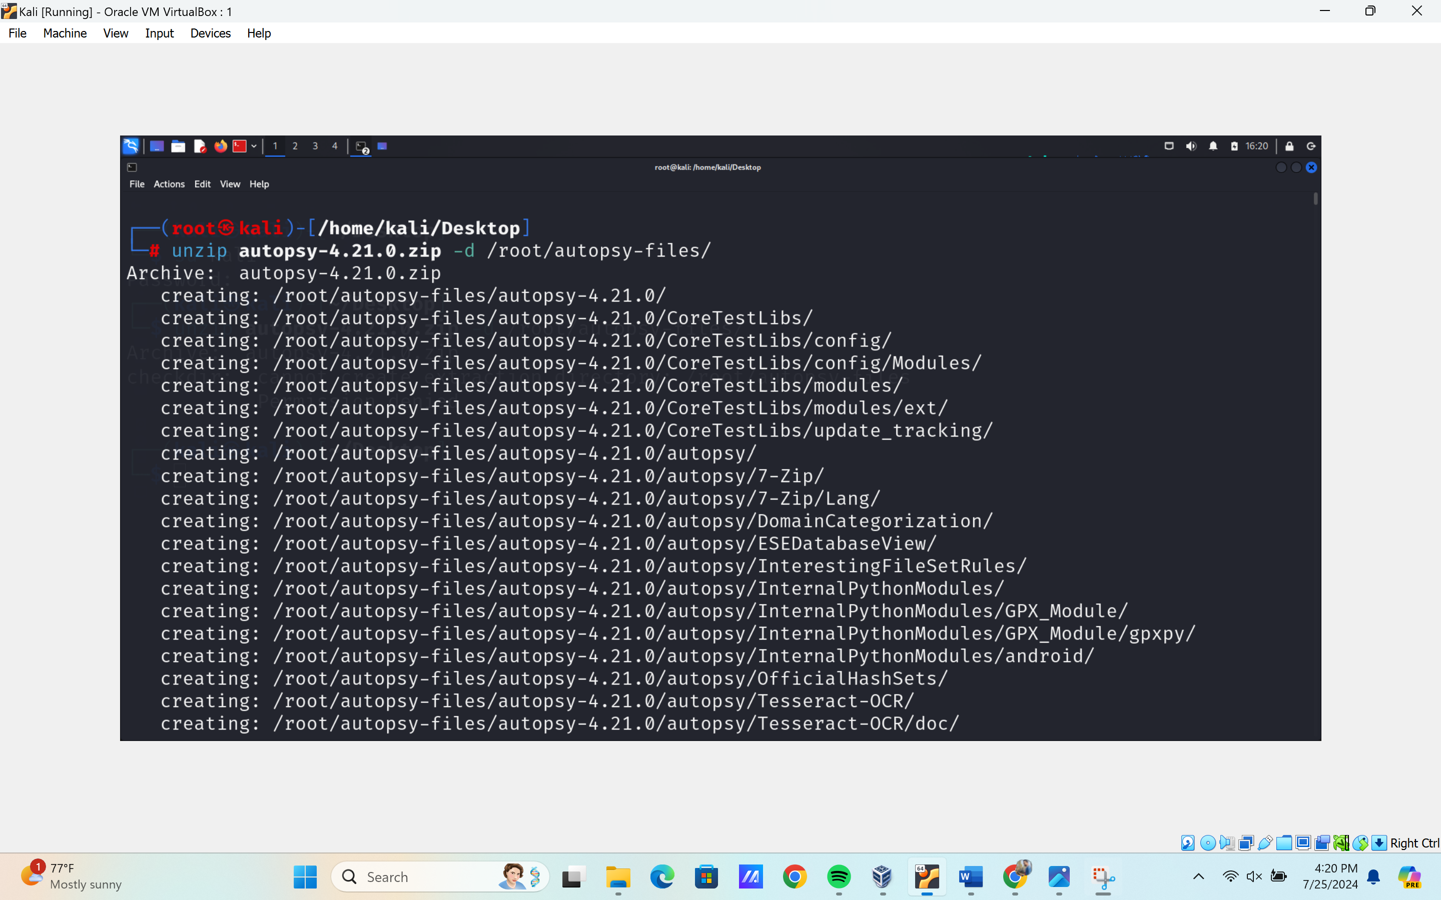

Navigate to: /root/autopsy-files/autopsy-4.10.0/bin

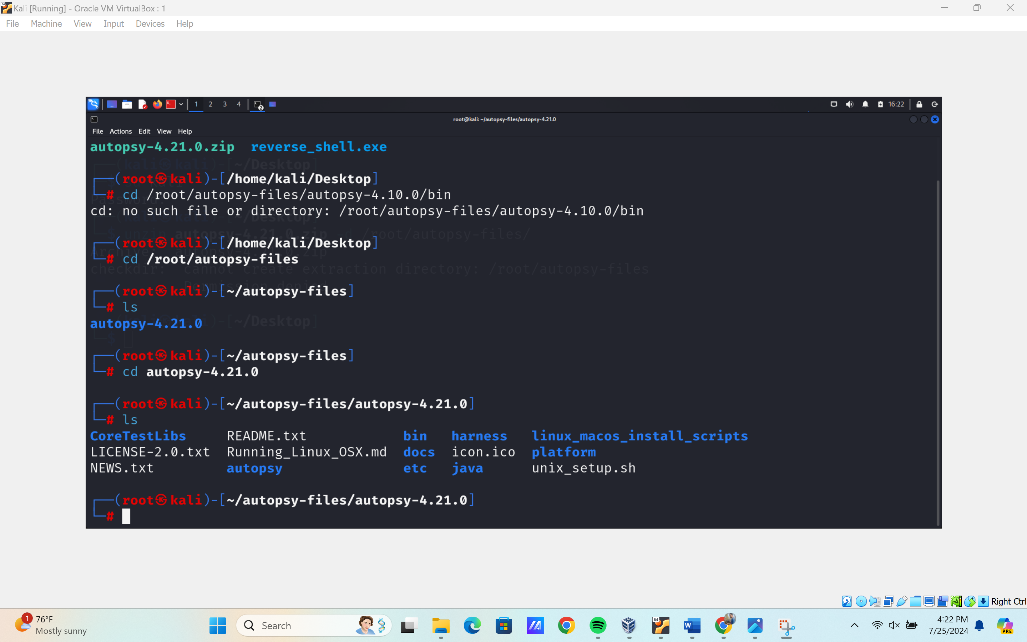

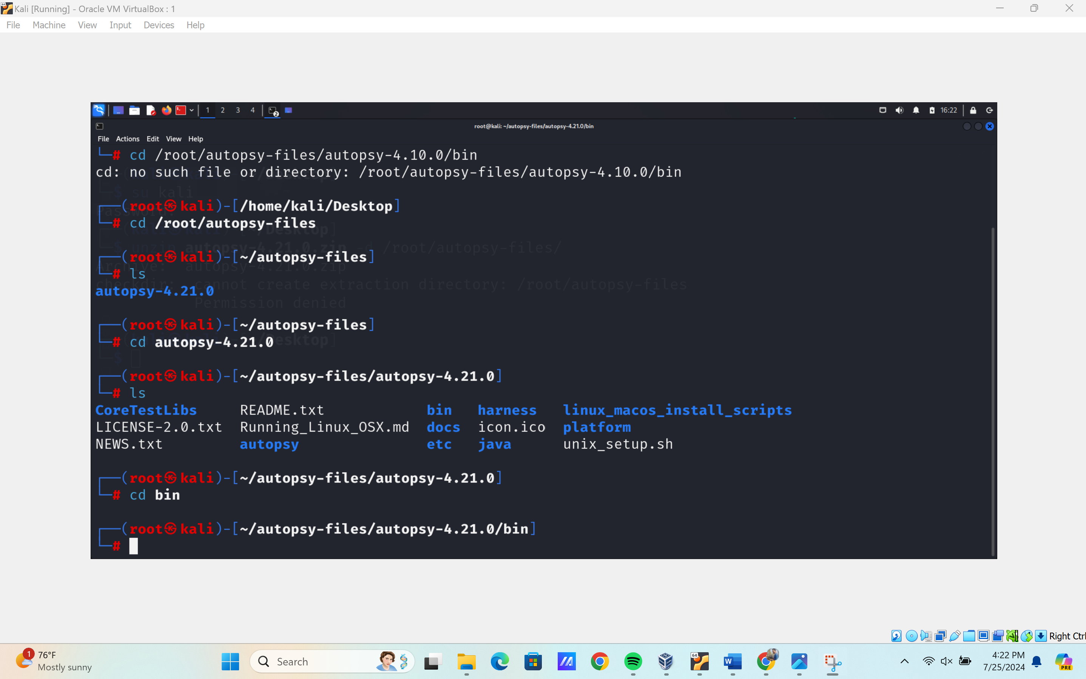

* + Run ./autopsy to launch Autopsy.

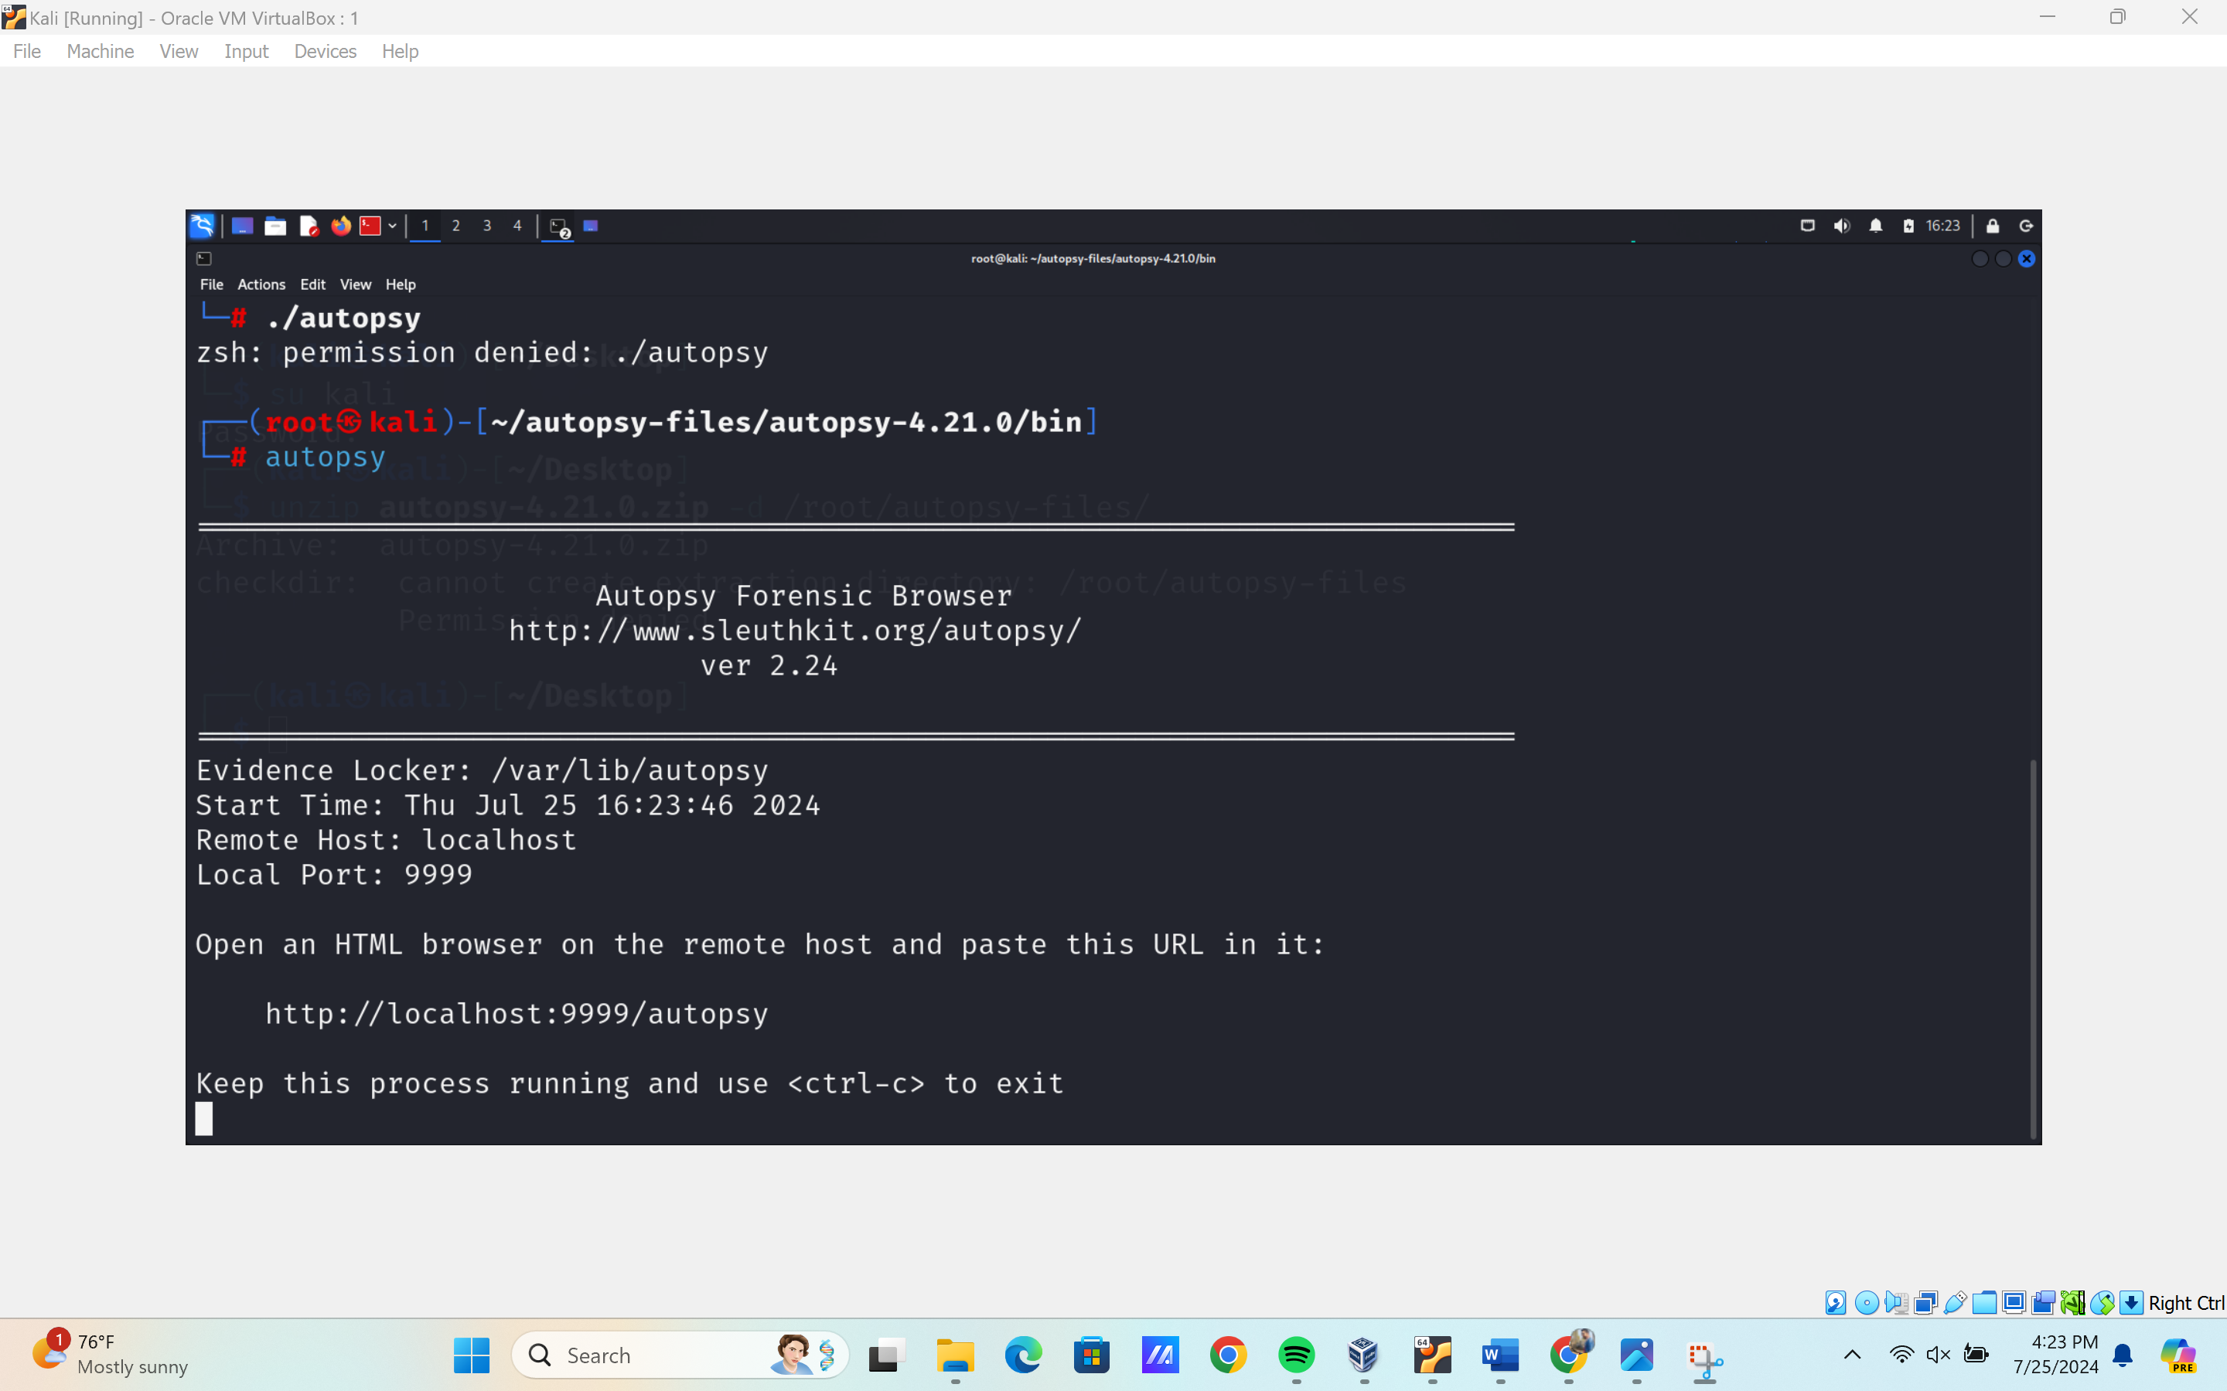

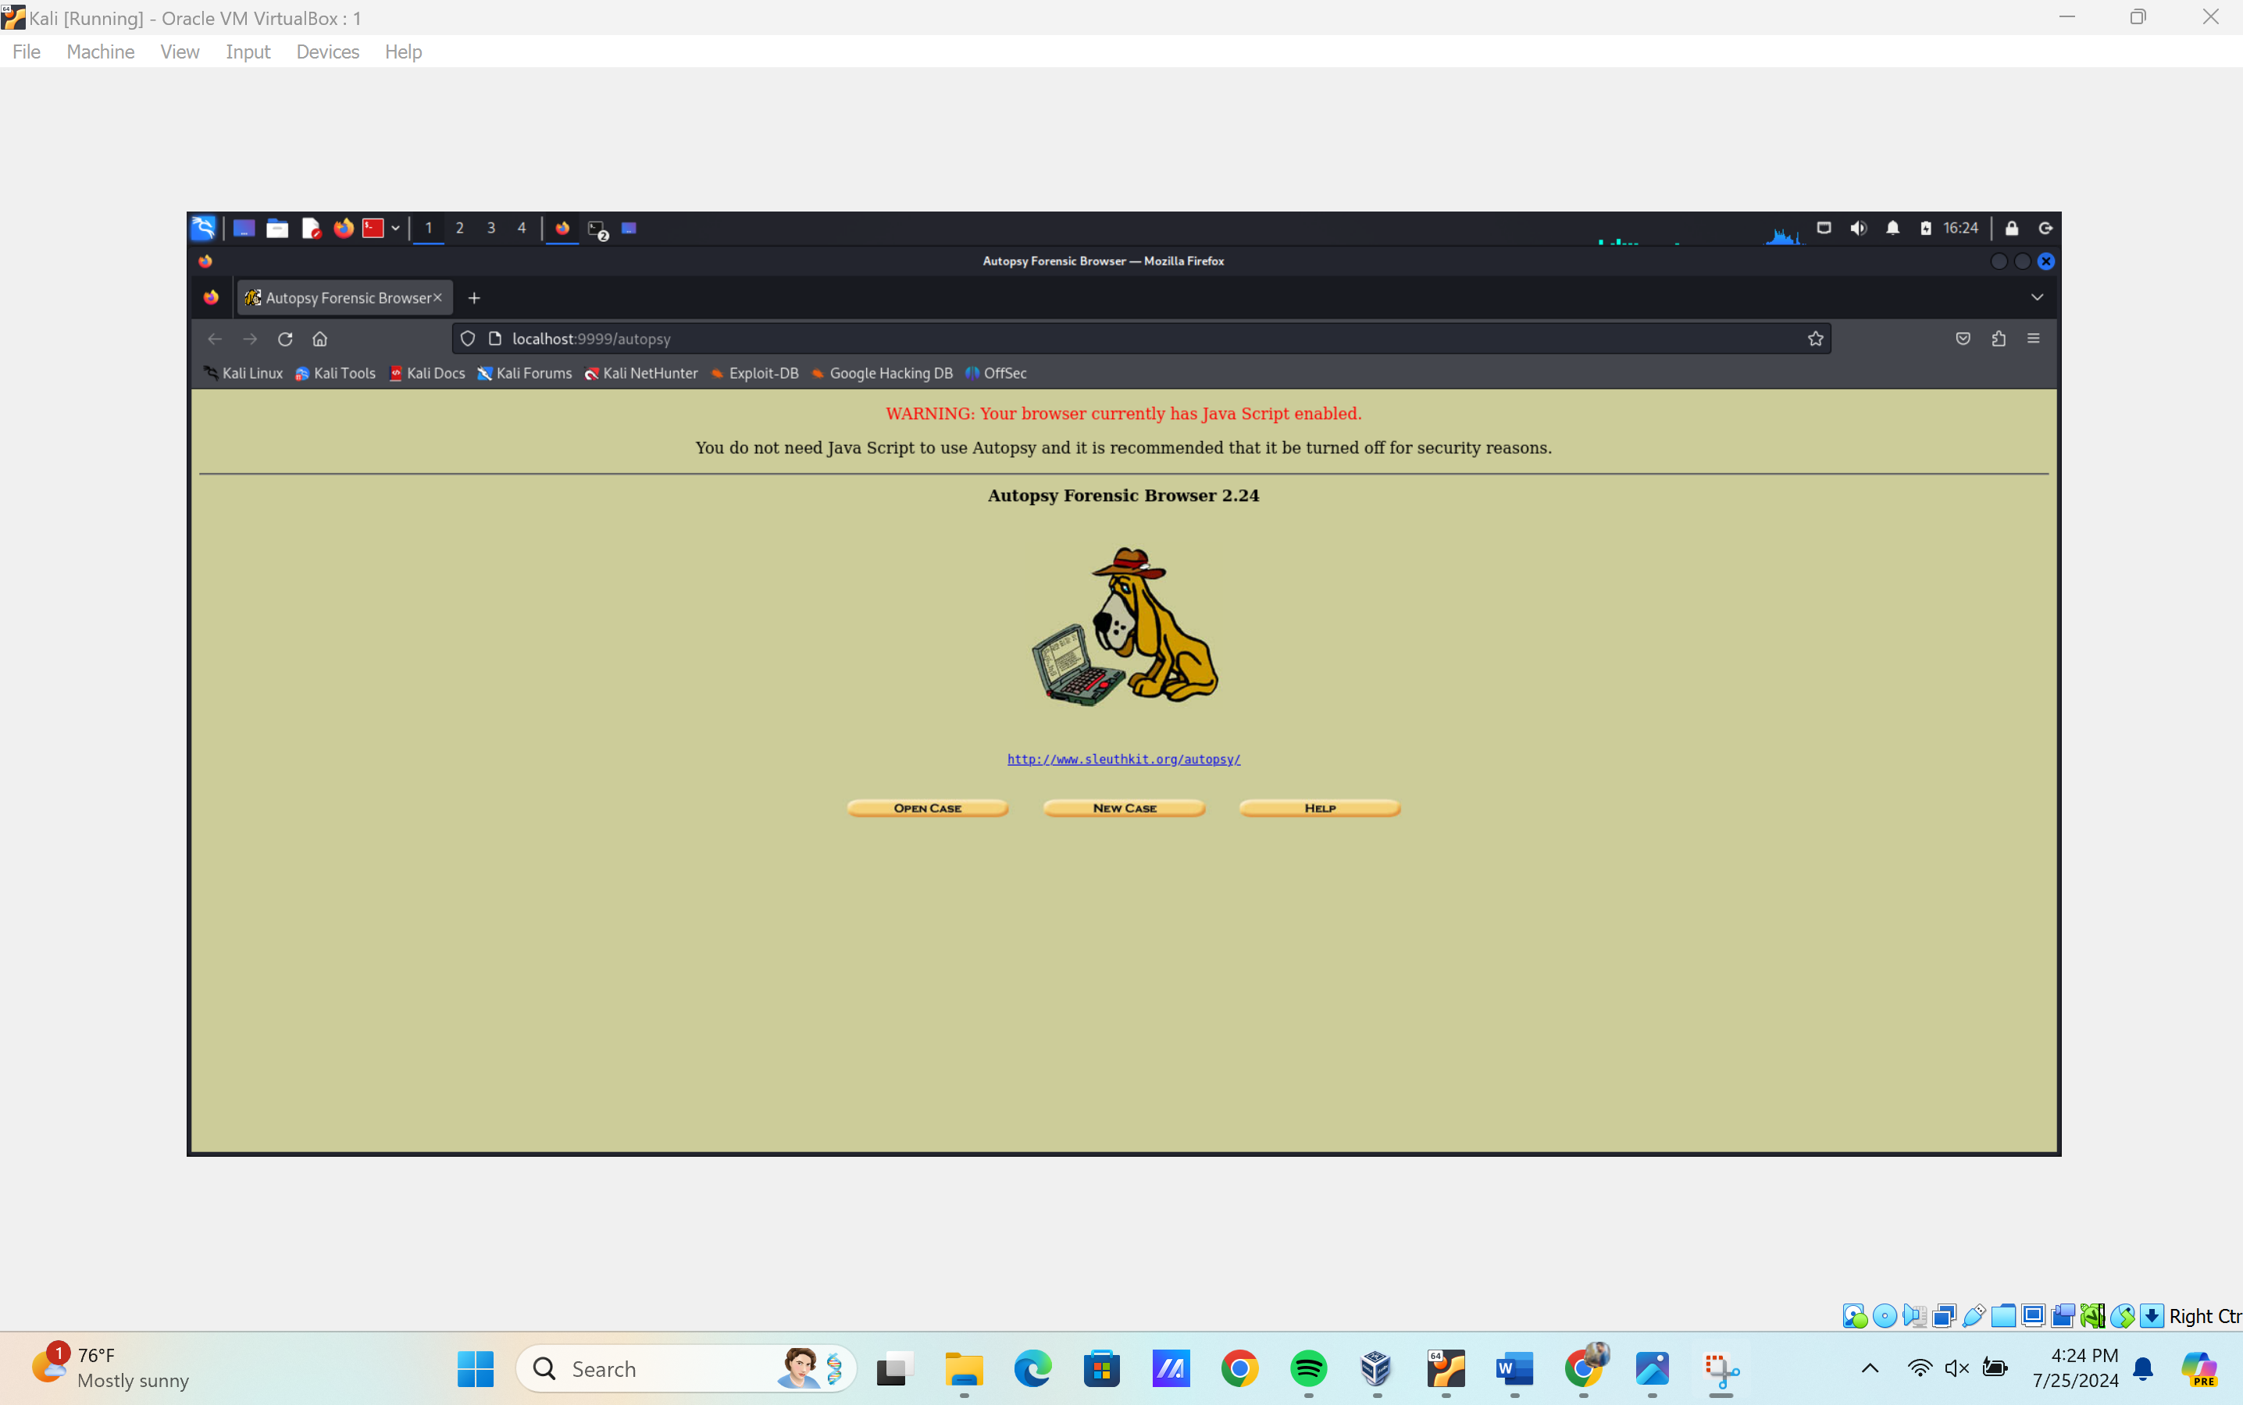

* + Open the recent case:

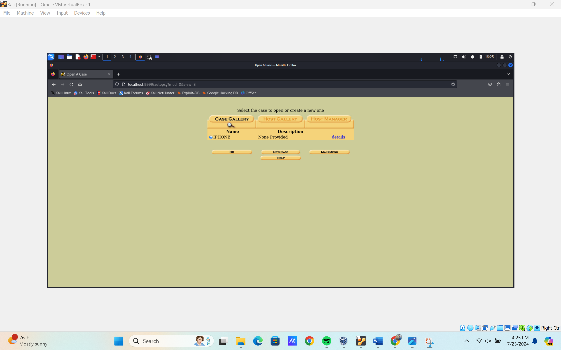

* + - Case name: 2012-07-15-National-Gallery
    - Case number: 1EZ215-P

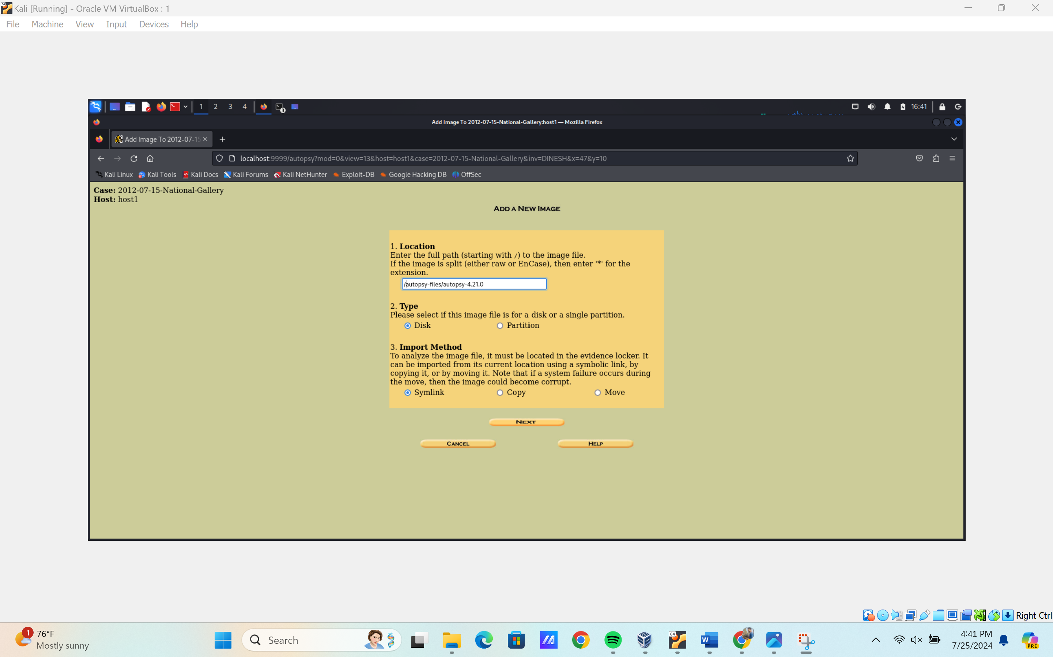

Add the image file  
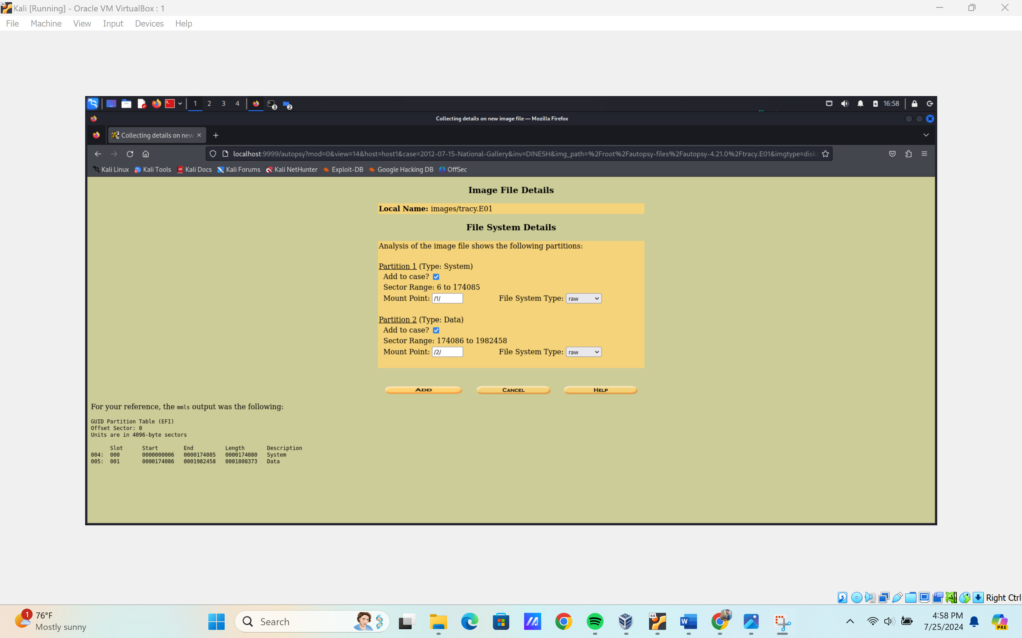

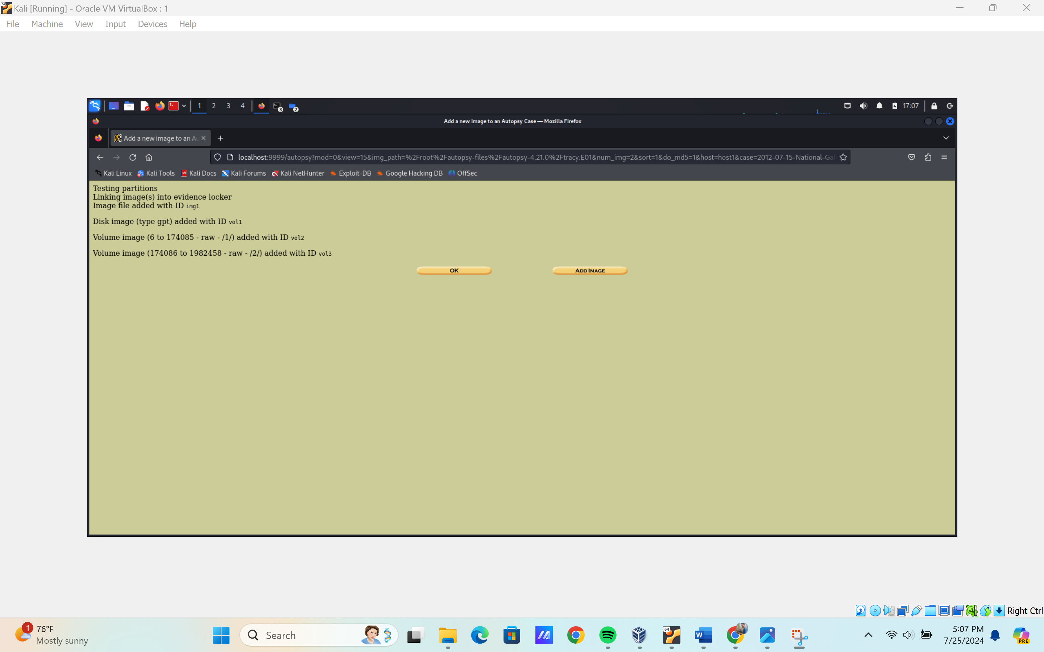

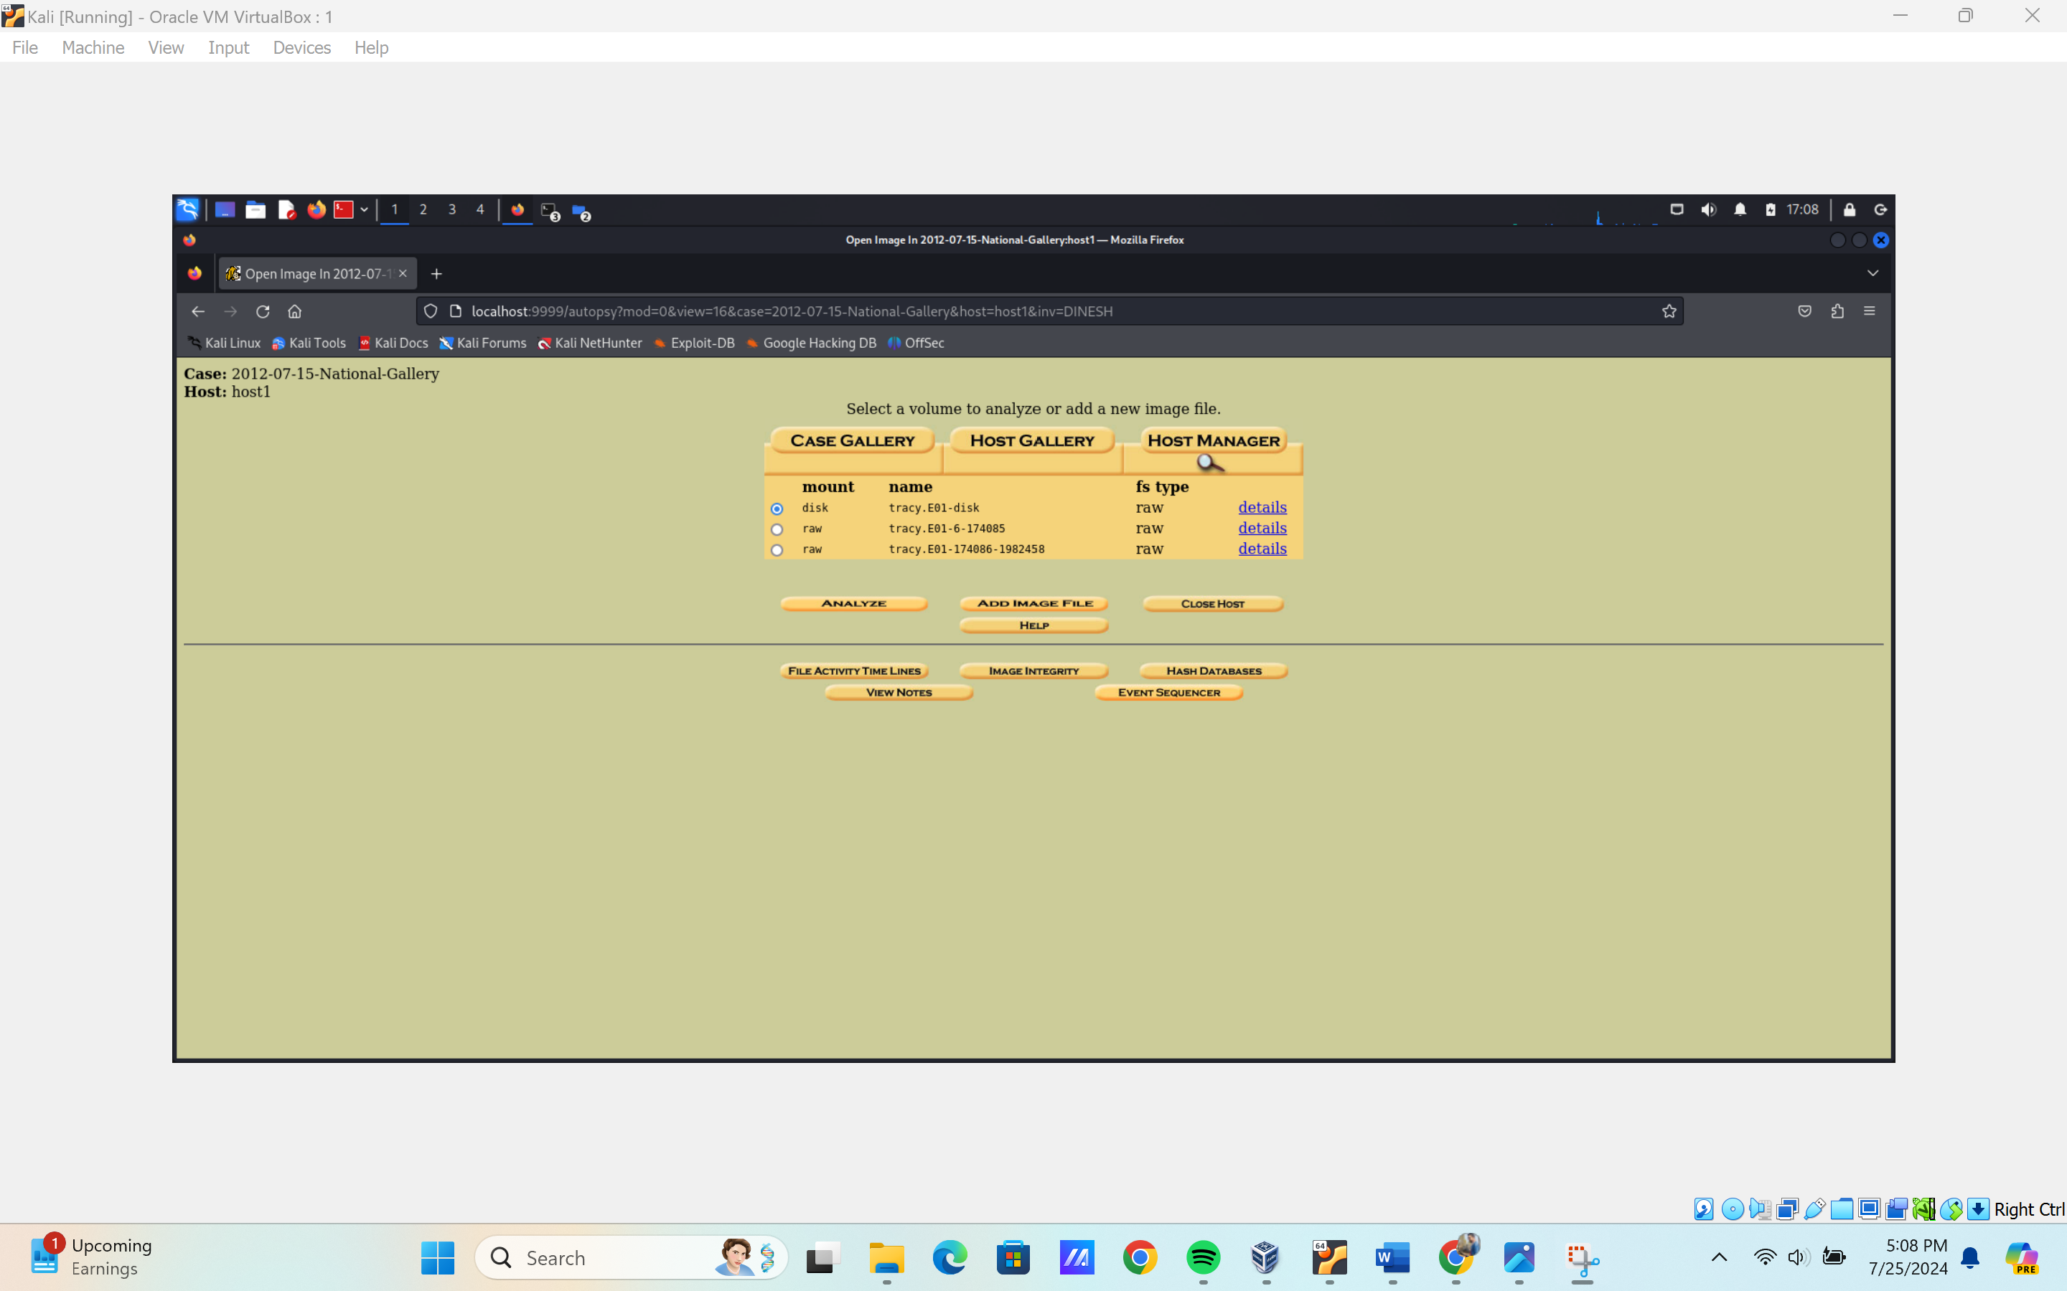

1. Locate and view emails and attachments:
   * Open a new terminal window.
   * Navigate to the directory in Kali Linux that contains the INBOX.mbox/Messages folder.
   * Once there, perform the following tasks:
     + Using Nano, open each file with the .emlx extension.
     + Scan through each email from top to bottom.
     + Look for email addresses and view the correspondence.

NOTE: the data I downloaded from the link: <https://corp.digitalcorpora.org/corpora/scenarios/2012-ngdc/tracy-phone/>

|  |
| --- |
| **I am not able to extract the fat12 file system because it does not allow me to change the file system which was in raw file. In raw file sqlite3 database browser can’t work. It should be on filesystem ft12, ft16, ft32 and NTFS.** |

1. Document your findings from the email evidence in the **Correspondence Evidence Worksheet.**
   * Fill out the following information in the Correspondence Worksheet.
     + Artifact numbers to help organize records
     + Timestamp (time email was sent or received)
     + Header information
       - These should include the individuals involved, their email addresses, and the subject line of the email.
     + Key information - Summary of the email content.
     + Evidence location
2. Phone Number: (703) 340-9661!
3. ● Email: tracysumtwelve@gmail.com!
4. ● Work email: tracy.sumtwelve@nationalgallerydc.org

**Phone Number: (703) 340-9661  
● Email:** [**tracysumtwelve@gmail.com**](mailto:tracysumtwelve@gmail.com) **● Work email:** [**tracy.sumtwelve@nationalgallerydc.org**](mailto:tracy.sumtwelve@nationalgallerydc.org)

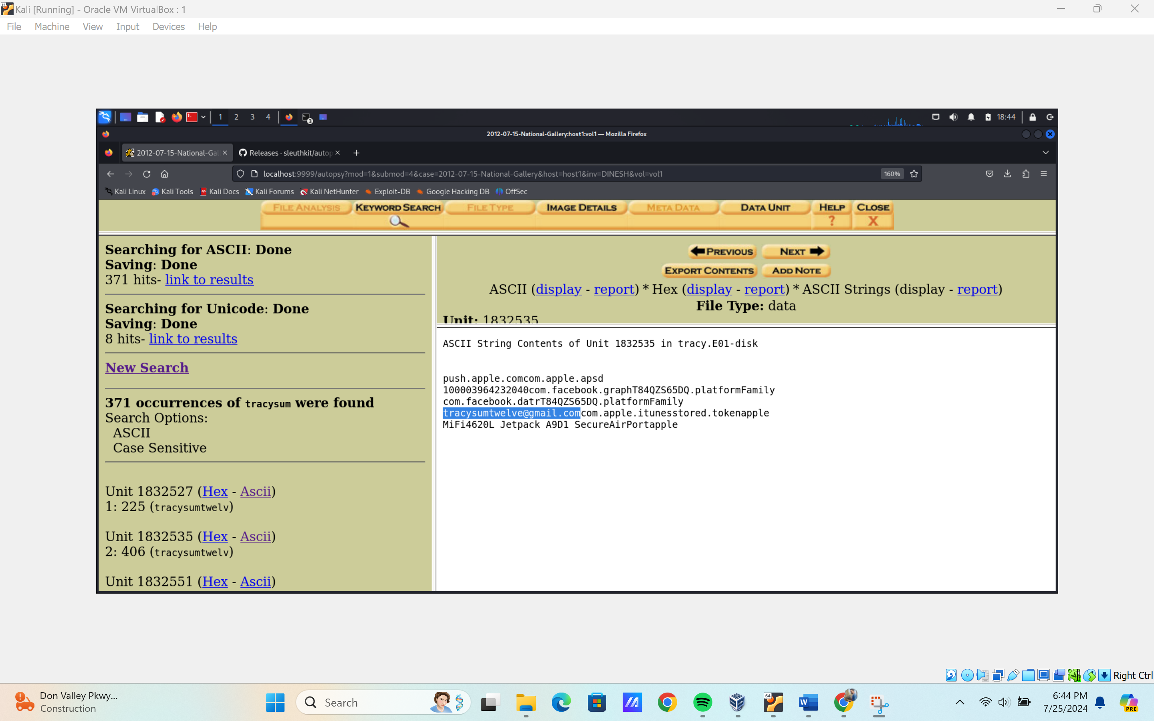

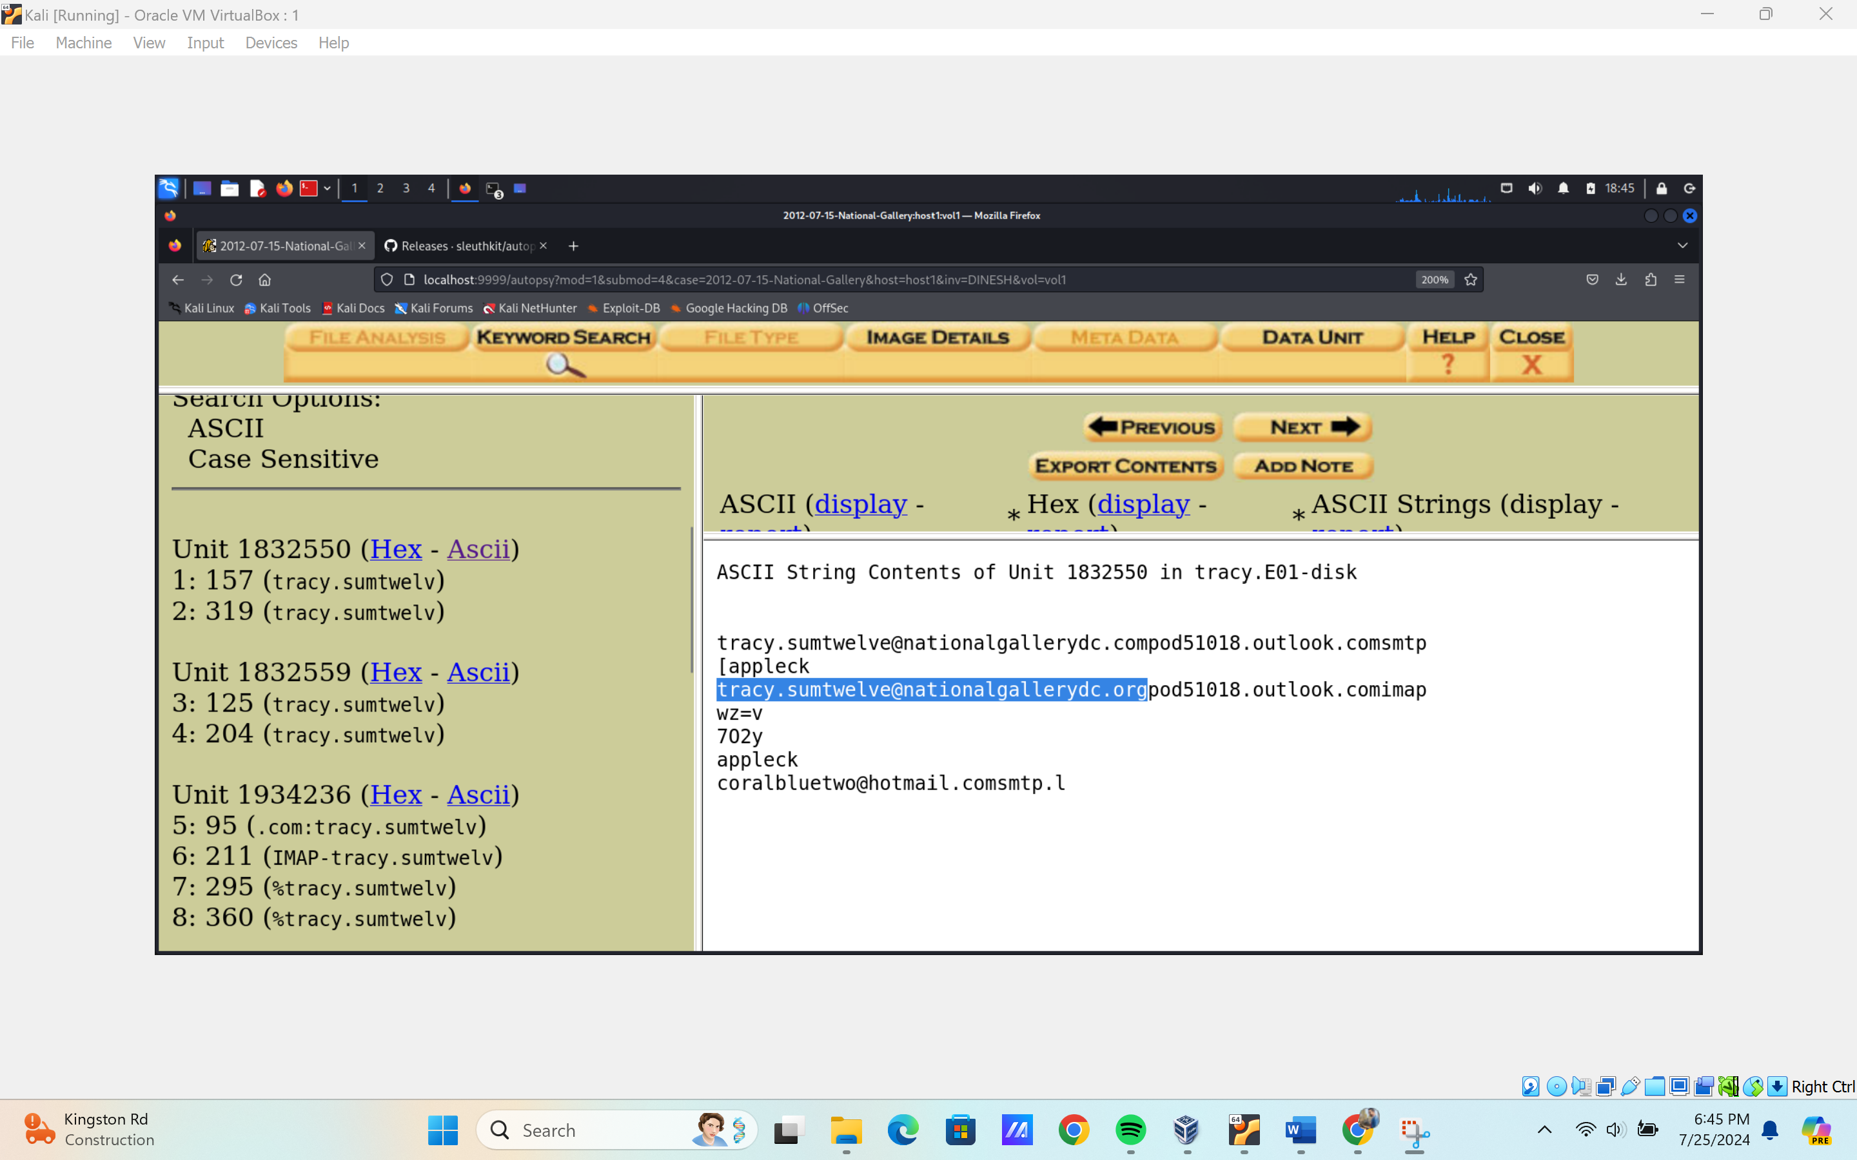

**The email are extracted from** /root/Library/Lockdown/activation_records/wildcard_record.plist

1. Did you find any incriminating evidence inside any of the emails or attachments? No, but do find some text messages where no person track was there  
   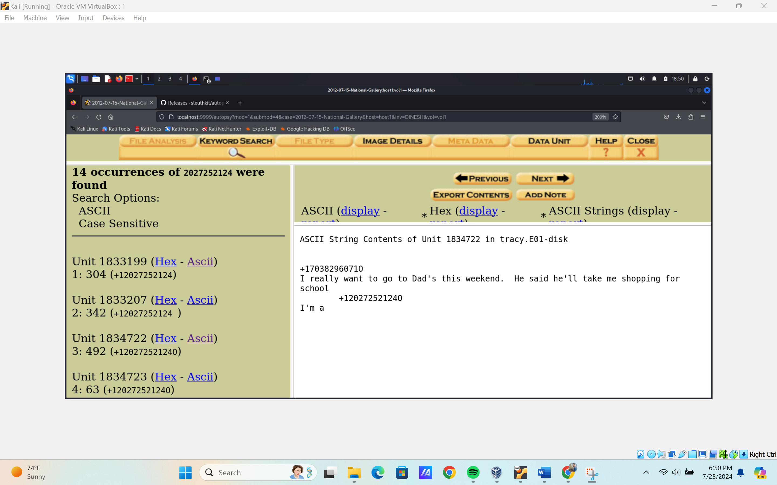

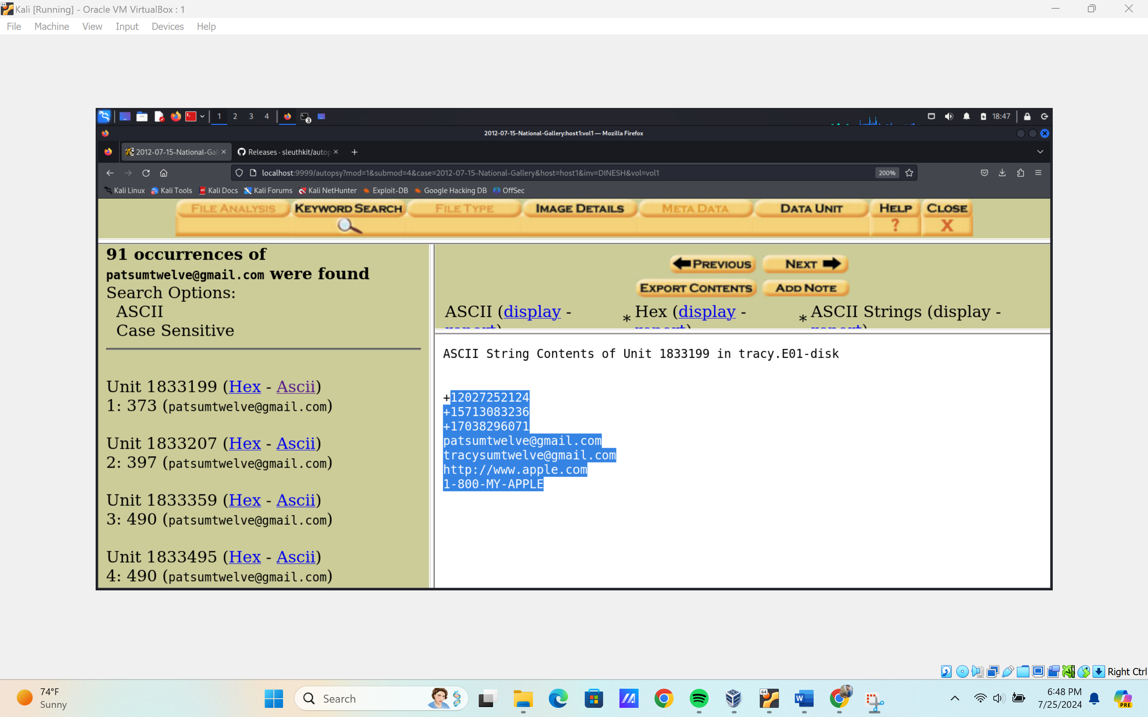

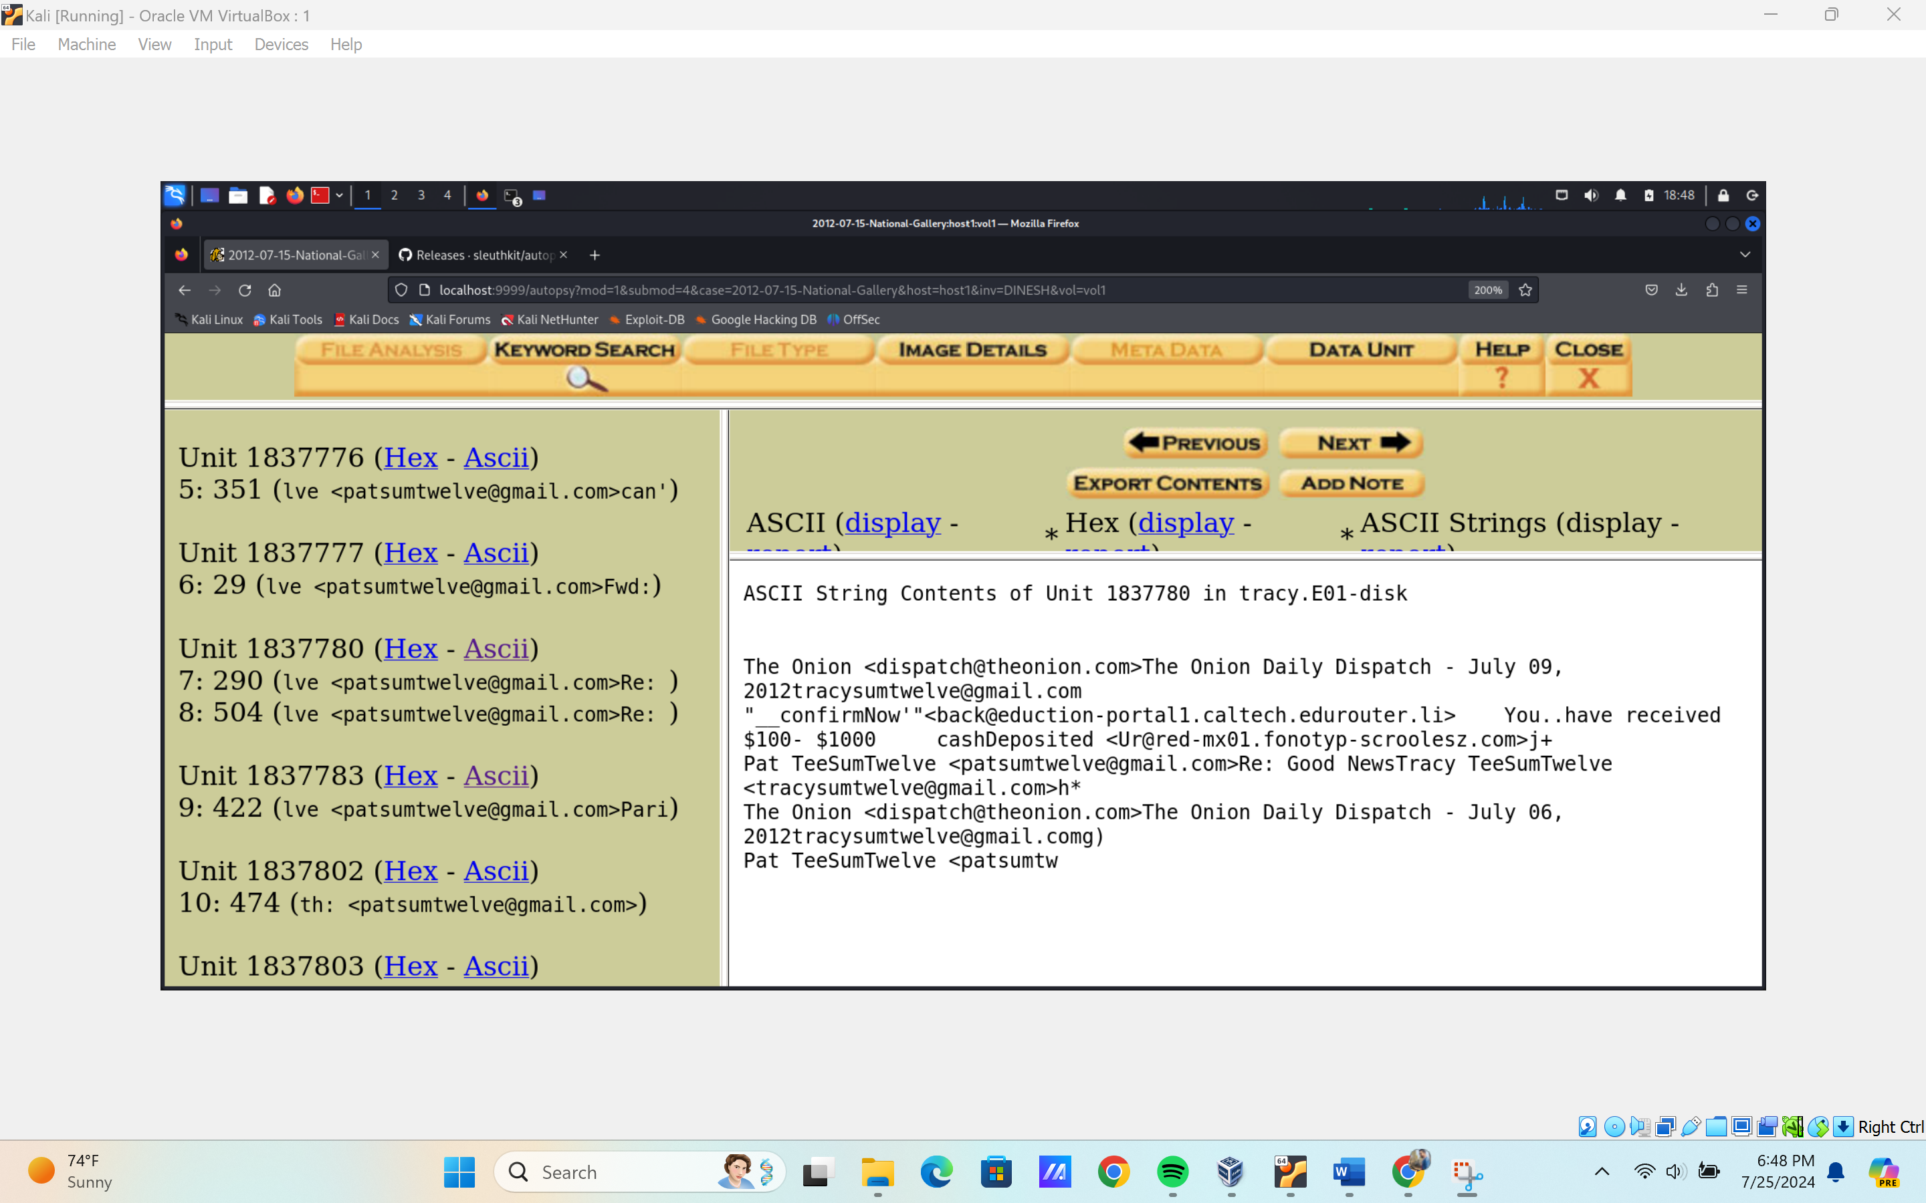

**Activity File: Tracy's SMS Messages**

* In this activity, you will continue to work with your group as a digital forensic team.
* You will examine Tracy's SMS messages and correlate phone numbers with co-conspirators.

**Instructions**

1. Use keyword search to find sms.db.

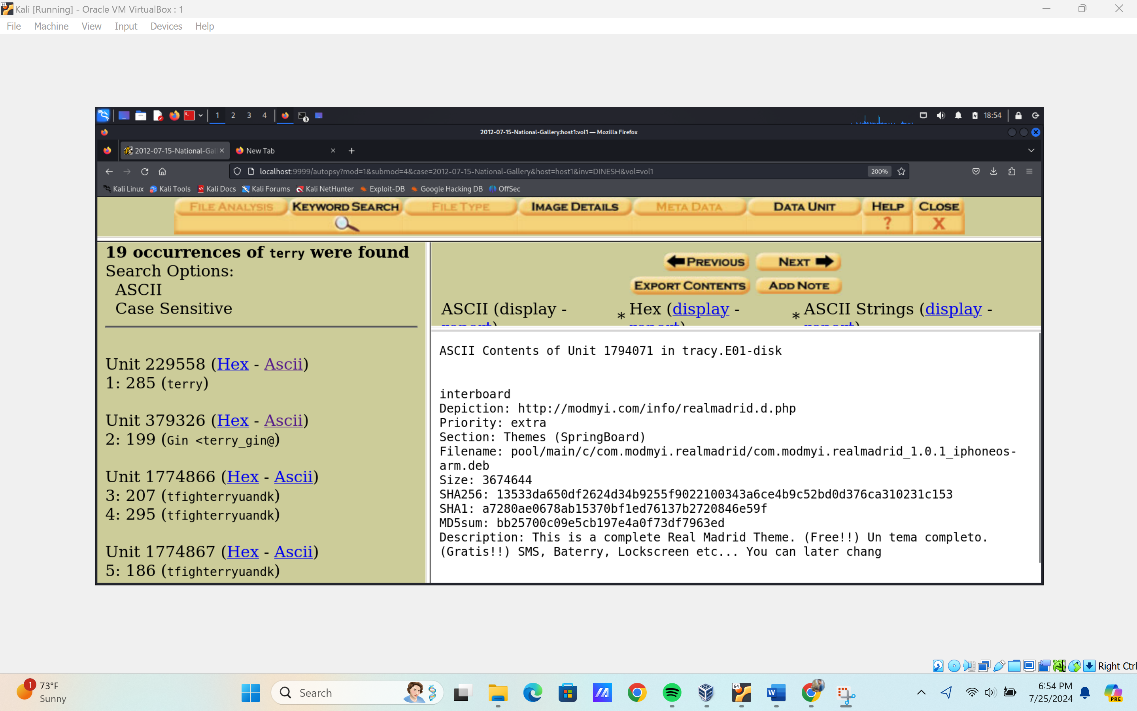

1. Add a custom tag called **sms**.
2. View the messages in the **Data Content** pane.

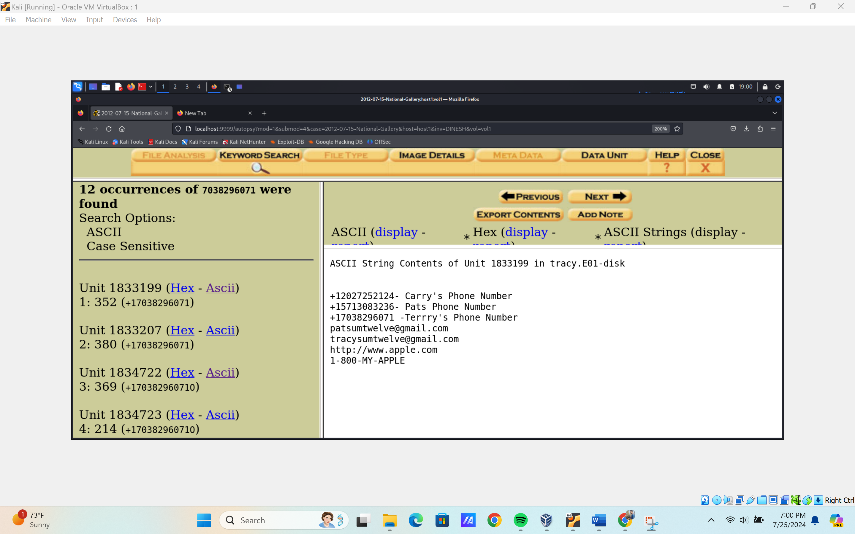

1. Analyze the SMS messages and phone numbers to establish connections to the case. Answer the following questions:



* + What is Terry's phone number? How do you know?

**(703) 829-6071**

* + What is Pat's phone number? How do you know?

**(571) 308-3236**

* + What is the fraudulent number that texted about a gift card?
    - Is this relevant to the case? Why or why not?

**Can’t get fraudulent number, but can extract:**

